# Setting and Removing Indexes

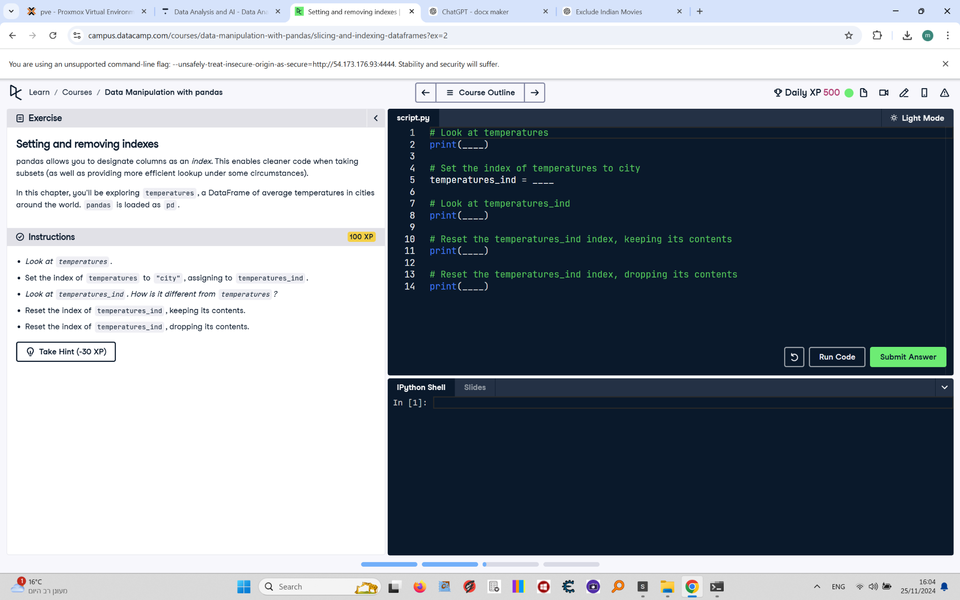

pandas allows you to designate columns as an index. This enables cleaner code when taking subsets (as well as providing more efficient lookup under some circumstances).  
  
In this chapter, you'll be exploring temperatures, a DataFrame of average temperatures in cities around the world. pandas is loaded as pd.

## Final Answer

# Look at temperatures  
print(temperatures)  
  
# Set the index of temperatures to city  
temperatures_ind = temperatures.set_index("city")  
  
# Look at temperatures_ind  
print(temperatures_ind)  
  
# Reset the temperatures_ind index, keeping its contents  
print(temperatures_ind.reset_index())  
  
# Reset the temperatures_ind index, dropping its contents  
print(temperatures_ind.reset_index(drop=True))